
Attendance Policy
1
Academic Year 2026-20267
Version and Date |  | Action/Notes | Date Written | Date to be Reviewed
2.0 | 08.07.2025 | Approved by the Trust Board | Updated May 2025 | 1 Year – July 2026
3.0 | 30.06.2026 | Approved by the Trust Board | Reviewed May 2026 | 1 Year – June 2027

Aims
We are committed to meeting our obligations with regards to school attendance by:
- Improving attendance is everyone’s business, it must be a concerted effort across all teaching and non-teaching staff in school, the trust or governing body, the local authority, and other local partners.
- Promoting good attendance and reducing absence, including persistent absence
- Ensuring every pupil has access to full-time education to which they are entitled
- Acting early to address patterns of absence
- Set high expectations for the attendance and punctuality of all pupils and communicate these regularly to pupils and parents/carers through all available channels
- Proactively manage and improve attendance across the school community
- Working with pupils and parents/carers to remove any barriers to attendance and punctuality by building strong and trusting relationships and working together to put the right support in place
- Securing good attendance cannot therefore be seen in isolation, and effective practices for improvement will involve close interaction with schools’ efforts on curriculum, behaviour, bullying, special educational needs support, pastoral and mental health and wellbeing, and effective use of resources, including pupil premium

Legislation and Guidance
This guidance meets the requirements of the Working together to improve school attendance guidance from the Department for Education (DfE), and refers to the DfE’s statutory guidance on school attendance parental responsibility measures. These documents are drawn from the following legislation setting out the legal powers and duties that govern school attendance:
- Part 6 of The Education Act 1996
- Part 3 of The Education Act 2002
- Part 7 of The Education and Inspections Act 2006
- The Education (Pupil Registration) (England) Regulations 2024
- The Education (Penalty Notices) (England) (Amendment) Regulations 2013
- Working together to improve school attendance May 2022/September 2022

This policy also refers to the DfE’s guidance on the school census, which explains the persistent
absence threshold.

Roles and Responsibilities
Trust Board and Local Governing Bodies
The Trust Board and the Local Governing Bodies are responsible for monitoring attendance figures for the whole school on at least a termly basis. It also holds the Headteacher to account for the implementation of this policy. They will:
- Take an active role in attendance improvement, support their school(s) to prioritise attendance, and work together with leaders to set whole school cultures.
- Ensure school leaders fulfil expectations and statutory duties
- Use data to understand patterns of attendance, compare with other local schools, identify areas of progress and where greater focus is needed.
- Ensure school staff receive training on attendance.
- Regularly review attendance data and help school leaders focus support on the pupils who need it.

Headteacher
The Headteacher is responsible for:
- Implementation of this policy at the school
- Develop and maintain a whole school culture that promotes the benefits of good attendance
- Monitoring school-level absence data and reporting it to governors
- Issuing fixed-penalty notices, where necessary

Senior attendance champion: Named Person
The designated senior leader is responsible for:
- Championing and improving attendance in school
- Set a clear vision for improving and maintaining good attendance
- Evaluate and monitor expectations and processes
- Establish and maintain effective systems for tackling absence
- Have a strong grasp of absence data, regularly monitoring data to identify patterns and trends
- Communicate messages to pupils and parents/carers
- Work with each identified pupil and their parents to understand and address the reasons for absence
- Where out of school barriers are identified, signpost and support access to any required services
- Take an active part in the multi-agency effort with the local authority and other partners
- Advise the Headteacher when to issue fixed-penalty notices
- Advise the Headteacher when to issue fixed-penalty notices

Attendance Officer: Names person
The school Attendance Officer:
- Accurately complete admission and attendance register and record absences as reported by parents.
- Carries out first day calling where absence has not been reported.
- Reports concerns about attendance to the Designated Senior Leader
- Works with Education Welfare Officers to tackle persistent absence
- Arranges calls and meetings with parents/carers to discuss attendance issues

For any matter related to attendance Named person can be contacted by calling the school office or emailing: add email address

Local authority
- Discuss and signpost or provide access to services for pupils who are persistently or severely absent or at risk of becoming so.
- Take an active part in the multi-agency effort with the school and other partners.
- Provide the lead practitioner in cases where threshold is met and all partners agree that a local authority service is best placed to lead.
- Work jointly with the school to provide formal support options including attendance contracts and education supervision orders
- Where there are safeguarding concerns, ensure joint working between the school, children’s social care services and other statutory safeguarding partners
- Where support is not working, being engaged with or appropriate, enforce attendance through legal intervention (including prosecution as a last resort)

School Office Staff
School office staff take calls from parents/carers about absence and record it on the school
management information system.

Class Teachers
Class teachers are responsible for recording attendance on a daily basis, using the correct codes and submitting this information to the school office. Class teachers are also responsible for reporting any concerns around attendance they may have.

Parents
  - Ensure their child attends every day the school is open except when a statutory reason applies.
  - Notify the school as soon as possible when their child has to be unexpectedly absent (e.g. sickness).
  - Only request leave of absence in exceptional circumstances and do so in advance.
  - Book any medical appointments around the school day where possible.
  - Work with the school and local authority
  - Proactively engage with the support offered

Further details on roles and responsibilities can be found in:
Summary table of responsibilities for school attendance

Recording Attendance Attendance Register
Each school will keep an attendance register electronically and place all pupils onto this register. Each school will take an attendance register at the start of the first session of each school day and once during the second session. It will mark whether every pupil is:
- Present
- Attending an approved off-site educational activity
- Absent
- Unable to attend due to exceptional circumstances

Any amendment to the attendance register will include:
- The original entry
- The amended entry
- The reason for the amendment
- The date on which the amendment was made
- The name and position of the person who made the amendment
A pupil’s name can only lawfully be deleted from the admission register if a reason set out in regulation 9 of the School Attendance (Pupil Registration) (England) Regulations 2024 applies.
See Appendix 1 for the DfE attendance codes.
Each school will keep every entry on the attendance register for 6 years after the date on which the entry was made.

Lateness and Punctuality
  - The school day starts at peronalise e.g.8:45am where all children are offered breakfast. All pupils should arrive at school on time, ready for learning.
  - Registers are taken at personalise e.g 9:00am. Pupils arriving after the register has been taken will be marked as late (L)
  - Pupils arriving after xxxx am will be marked as unauthorised lateness (U). All pupils should arrive at school on time, ready for learning.
  - Our attendance officer and senior leaders will discuss lateness with parents daily.
At school name punctuality is monitored and persistent lateness that becomes a concern can result in a
referral to the education welfare officer.
At school name school the afternoon sessions start at xxxx pm and registers are not kept open.
School finishes at xxxxpm and it is expected that children are collected promptly. If children are not collected by xxxxpm they will be xxxxxxx personalise based on school procedure. Upon repeated late collection, children will attend after school club where parents may be charged for this service.

Following Up Absence
Where any child we expect to attend school does not attend, or stops attending, each school will:
  - Follow up on their absence with their parent/carer to ascertain the reason
  - Ensure proper safeguarding action is taken where necessary
  - Identify whether the absence is approved or not
  - Identify the correct attendance code to use
At (Insert school name and adapt procedure) a text is sent to all parent’s whose child is absent from school. First day calling will then take place and if school fails to make contact home visits are carried out as necessary.

Unplanned Absence
Each school marks absence due to illness as authorised unless the school has a genuine concern about
the authenticity of the illness.
If the authenticity of the illness is in doubt, the school may ask the pupil’s parent/carer to provide medical evidence, such as a doctor’s note, prescription, appointment card or other appropriate form of evidence. We will not ask for medical evidence unnecessarily.

If the school is not satisfied about the authenticity of the illness, the absence will be recorded as unauthorised and parents/carers will be notified of this in advance.
At (Insert school name and adapt procedure) the pupil’s parent/carer must notify the school on the first day of an unplanned absence by [9.00am] or as soon as practically possible.

This can be done via contacting the school on xxxxxxxx or by emailing the school detailing the absence on email address

Planned Absence
We strongly encourage parents/carers to make medical and dental appointments out of school hours where possible. Where this is not possible, pupils should be out of school for the minimum amount of time necessary.
Attending a medical or dental appointment will be counted as authorised as long as the pupil’s
parent/carer notifies the school in advance of the appointment.

Pupil’s parent/carers must apply for other types of term-time absence as far in advance as possible of the requested absence. (Section 5: Term-time absences the school can authorise)

At xxxxxxx school : Outline procedure – e.g. we ask all parents/carers to complete a request for absence form electronically or if unable to do so complete a form via the school office. The school will respond to each request individually in writing.

Request for absences
Headteachers will only grant a leave of absence to pupils during term-time if they consider there to
be 'exceptional circumstances'. A leave of absence is granted at the Headteacher’s discretion.

Each school considers each application for term-time absence individually, taking into account the current attendance, specific facts, circumstances and relevant context behind the request.
Attendance Monitoring
Each school monitors pupil absence regularly and thoroughly in order to:
- Track the attendance of individual pupils
- Identify whether or not there are particular groups of pupils whose absences may be a cause for concern
- Monitor and evaluate those pupils identified as being in need of intervention and support.
Pupil-level absence data is collected each term and published at national and local authority level through the DfE's school absence national statistics releases. The underlying school-level absence data is published alongside the national statistics. Schools will compare attendance data to the national average and share this with the Trust Board and Local Governing Body.
At xxxxxxxx we regularly monitor individual absence but also at school level using View your school
School Attendance. We share our daily attendance data via share school attendance

Reducing Persistent Absence
The persistent absence threshold is 10%. If a pupil's individual overall absence rate is greater than or equal to 10%, the pupil will be classified as a persistent absentee and the school will put in support arrangements to address this as a matter of urgency.

At (Insert school name and adapt procedure) e.g. school absence is monitored weekly and any parent whose child’s absence becomes a concern will be invited to an attendance clinic with their child’s Assistant Headteacher. (where they will be able to see where their child’s attendance falls on our attendance ladder – see Appendix 3). Should these concerns continue parents will be invited to an attendance clinic with our Education Welfare Officer. Continual attendance concerns of 10% unauthorised absence are referred to the Education Welfare Officer. Please see Appendix 3.

Legal Sanctions
Where there are unresolved attendance concerns, our schools may issue a penalty notice, following the Enfield Local Authority framework ‘Code of Conduct for Issuing Education & Exclusion Related Penalty Notices January 2015’ and the Department for Education’s statutory guidance on school attendance parental responsibility measures.
The decision on whether or not to issue a penalty notice includes consideration of:
- The threshold is 10 sessions of unauthorised absence in a rolling period of 10 school weeks
If issued with a penalty notice, each parent/carer must pay £80 within 21 days or £160 within 28 days. The payment must be made directly to the local authority. If the payment has not been made after 28 days, the local authority can decide whether to prosecute or withdraw the notice.

Strategies for Promoting Attendance
Each school has a comprehensive range of strategies to promote good attendance, referring to strategies contained in the guidance from the Department for Education.

At (Insert school name and adapt procedure) e.g.school attendance is celebrated weekly in our family assemblies. Classes who achieve the school’s target of 95% are rewarded with a star. Classes who achieve 5 stars can choose their own celebration reward.

Termly, the winning class in each year group is invited to a celebration and 100% attenders are rewarded with hot chocolate and biscuits with a member of the Senior Leadership team.

Annually, the winning family receive a visit from the ice cream van and 100% attenders are also
rewarded with a special treat.

Reporting to Parents/Carers
Each school reports to parents/carers on their child’s attendance record annually in the written end- of-year report. (Insert school name and adapt procedure) e.g. parents will also receive termly information regarding attendance at Parent Conferences.
Where there are concerns about a child’s attendance, each school has their own reporting procedure.

At xxxxxxxx school, should your child’s attendance become a concern the school will invite you in to discuss this and how we can work together to improve it. You may be invited to an attendance clinic with our Education Welfare Officer to discuss how we can work together to ensure your child attends school regularly.

Links with Other Policies
This policy links to the following policies:
- Child Protection and Safeguarding Policy
- Behaviour Policy

This policy meets the requirements of the school attendance guidance from the Department for Education (DfE) and refers to the DfE’s statutory guidance on school attendance parental responsibility measures. These documents are drawn from the following legislation setting out the legal powers and duties that govern school attendance Working together to improve school attendance - GOV.UK (www.gov.uk).
This policy also refers to the DfE’s guidance on the school census, which explains the persistent absence threshold. This policy complies with the Trust’s funding agreement and articles of association.

Appendix 1: Attendance Codes
The following codes are taken from the DfE’s guidance on school attendance.

Code | Definition | Scenario
/ | Present (am) | Pupil is present at morning registration
\ | Present (pm) | Pupil is present at afternoon registration
L | Late arrival | Pupil arrives late before register has closed
U | Arrival after registration | Pupil arrived at school after the register closed
O | Unauthorised absence | School is not satisfied with reason for pupil's absence
I | Illness | School has been notified that a pupil will be absent due to illness
M | Medical/dental appointment | Pupil is at a medical or dental appointment
R | Religious observance | Pupil is taking part in a day of religious observance
G | Unauthorised holiday | Pupil is on a holiday that was not approved by the school
C | Authorised leave of absence | Pupil has been granted a leave of absence due to exceptional circumstances
Attending a place other than at school
K | Educated by LA provision | Attending education provision arranged by the local authority that is not school
V | Educational trip or visit | Pupil is on an educational visit/trip organised, or approved, by the school
P | Sporting activity | Pupil is participating in a supervised sporting activity approved by the school
W | Work experience | Pupil is on a work experience placement
B | Off-site educational activity | Pupil is at a supervised off-site educational activity approved by the school
D | Dual registered | Pupil is attending a session at another setting where they are also registered
Absent – leave of absence or authorised reasons
C1 | Performing or employment | Pupil participating in a regulated performance or undertaking regulated employment abroad.
J1 | Interview | Pupil has an interview with a prospective employer/educational establishment
S | Study leave | Year 11 pupil is on study leave during their public examinations
X | Not required to be in school | Pupil of non-compulsory school age is not required to attend
C2 | Part time timetable | Pupil of compulsory school age is subject to a part-time timetable
Absence – Other authorised reasons
T | Gypsy, Roma and Traveller absence | Pupil from a Traveller community is travelling, as agreed with the school
E | Excluded | Pupil has been excluded but no alternative provision has been made
Absence – Unable to attend school because of unavoidable cause
Q | Unable to attend due to access arrangements | Pupil is unable to attend the school because the local authority has a duty to make access arrangements to enable the pupil’s attendance at school and have failed to do so.
Y1 | Unable to attend due to transport provided not being available | Pupil is unable to attend because the school is not within walking distance of their home and the transport that is normally provided by the school or local authority is not available.
Y2 | Unable to attend due to widespread travel disruption | Pupil is unable to attend because of widespread disruption to travel caused by a local, national, or international emergency.
Y3 | Unable to attend due to part of the school premises being closed | Part of the school premises is unavoidably out of use and the school cannot accommodate in those part of the premises that remain in use.
Y4 | Unable to attend due to the whole school site being closed | Where a school was planned to be open for a session, but the school is closed unexpectedly (e.g. due to adverse weather),
Y5 | Unable to attend as pupil is in criminal justice detention | The pupil is unable to attend the school because they are: in police detention, remanded to youth detention, awaiting trial or sentencing, or detained under a sentence of detention.
Y6 | Unable to attend in accordance with public health guidance or law | The pupil’s travel to or attendance at the school would be contrary to any guidance relating to the incidence or transmission of infection or disease published by the Secretary of State for Health and Social Care or prohibited by any legislation relating to the incidence or transmission of infection or disease.
Y7 | Unable to attend because of any other unavoidable cause | An unavoidable cause, that is not covered by one of the other ‘unable to attend’ codes detailed above, is preventing the pupil from attending the school.
Absent – Unauthorised absence
N | Reason not provided | Pupil is absent for an unknown reason (this code should be amended when the reason emerges, or replaced with code O if no reason for absence has been provided after a reasonable amount of time)
Administrative Codes
Z | Pupil not on admission register | Register set up but pupil has not yet joined the school
# | Planned school closure | Whole or partial school closure due to half- term/bank holiday/INSET day

Appendix 2: Working Together To Improve Attendance (DfE Feb 2024)

Successfully treating the root causes of absence and removing barriers to attendance, at home, in school or more broadly requires schools and local partners to work collaboratively in partnership with, not against families. All partners should work together to:
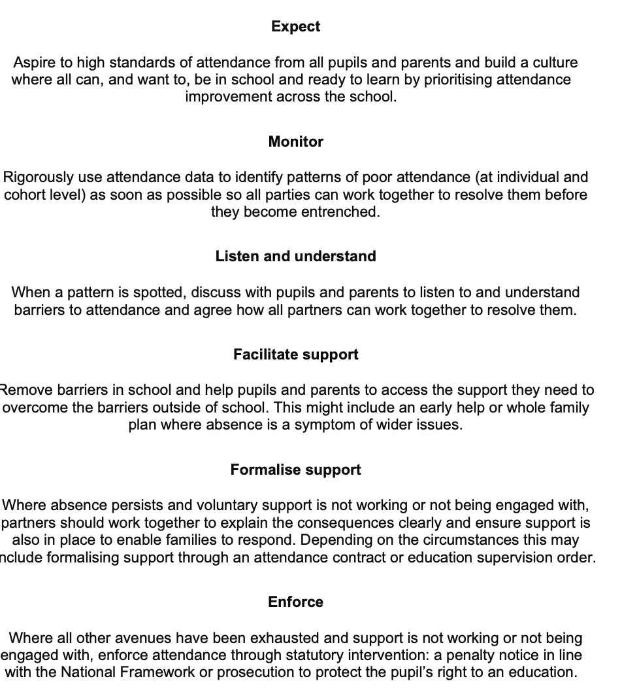

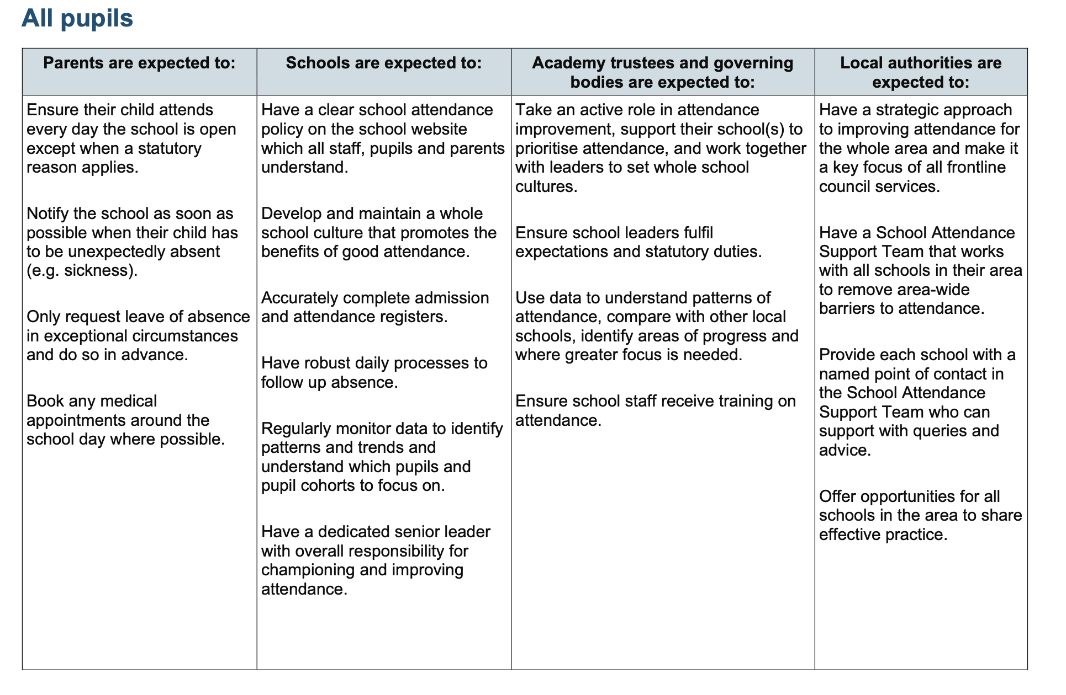
Appendix 3: Summary Table of responsibilities for school attendance 2024

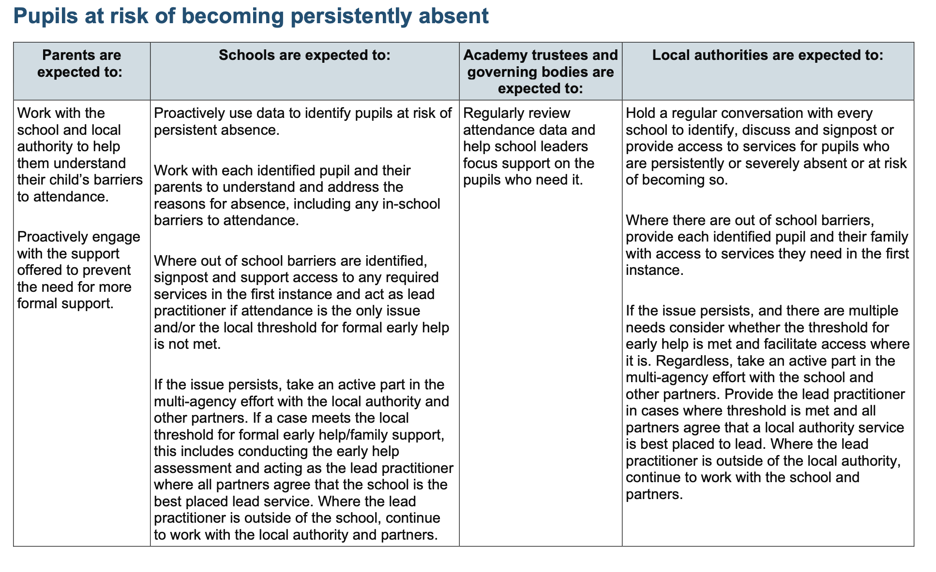

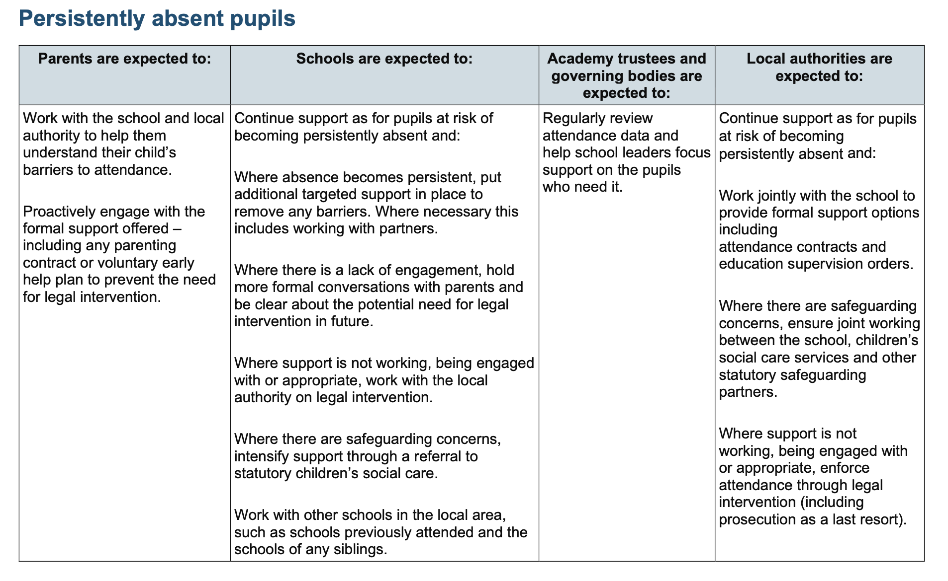
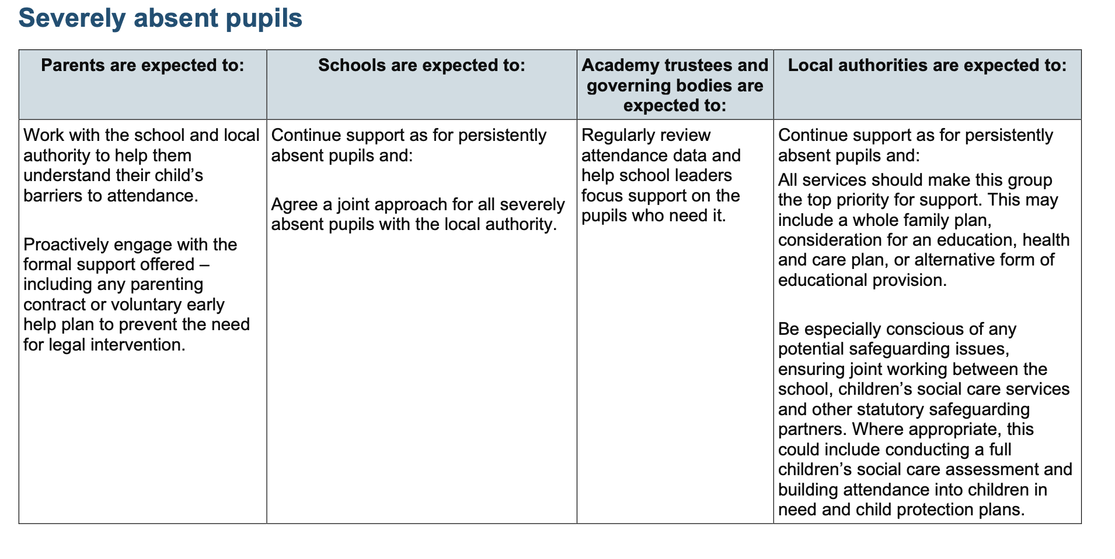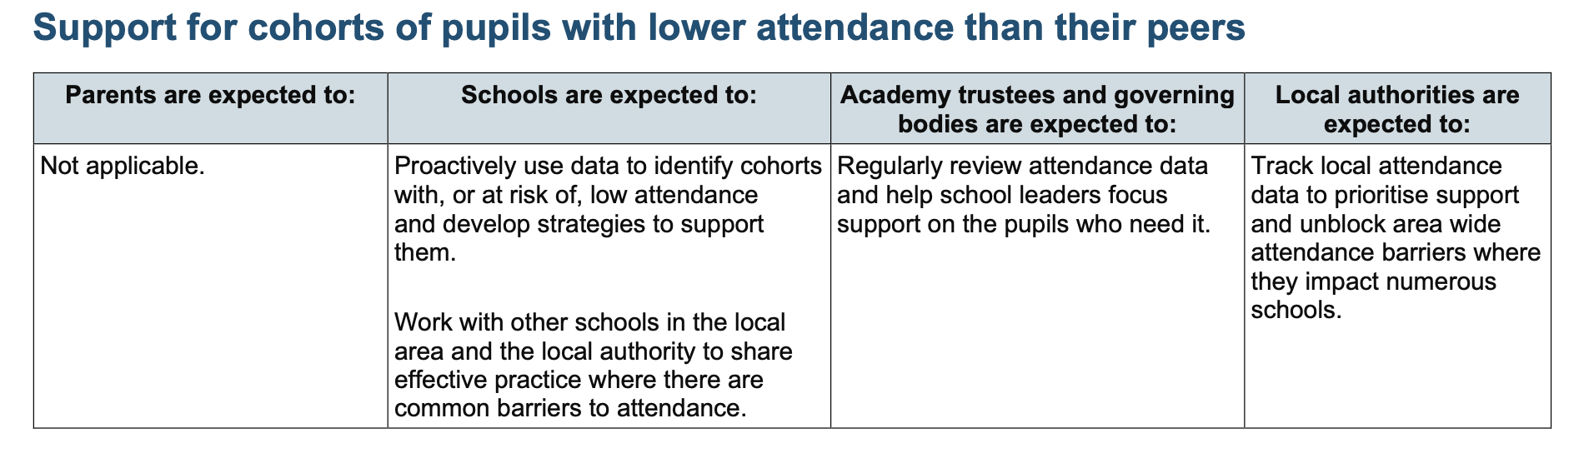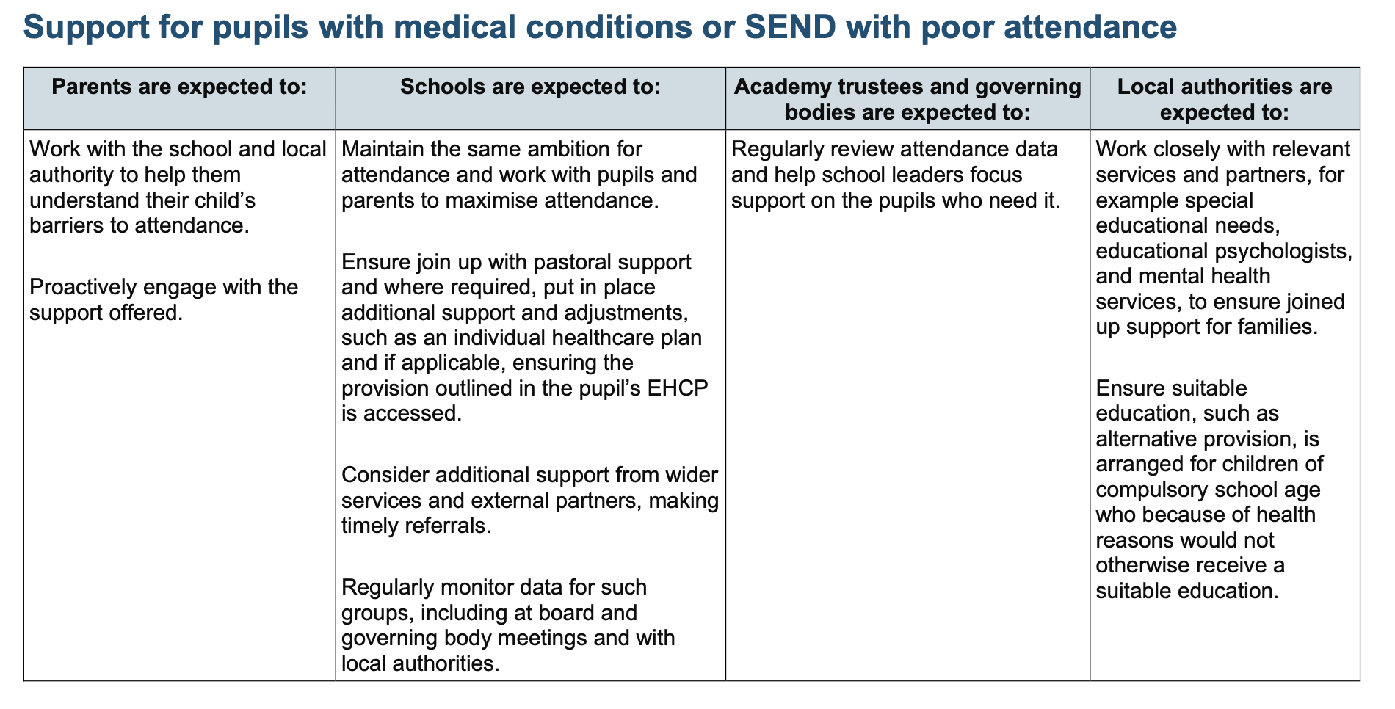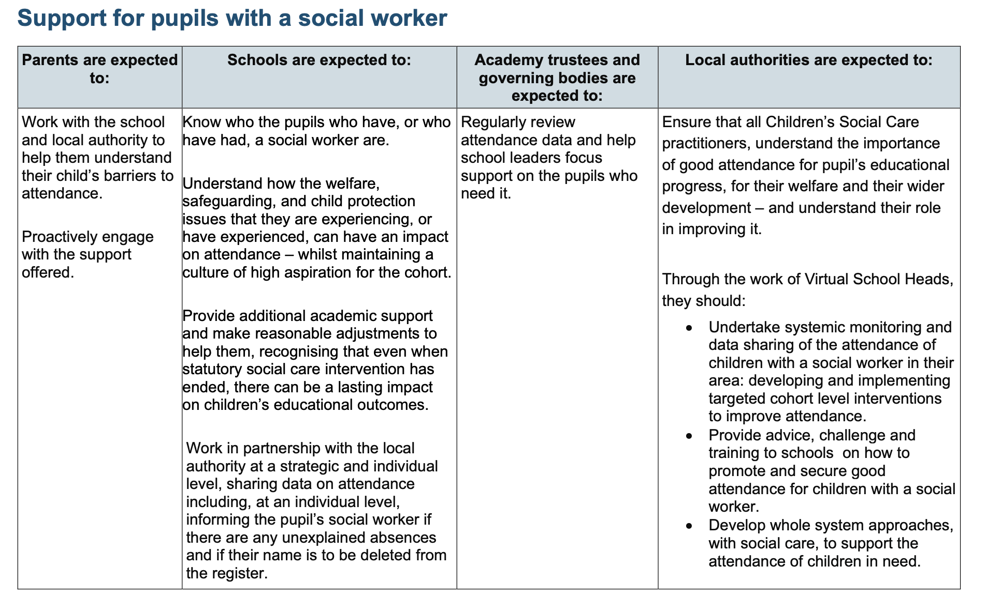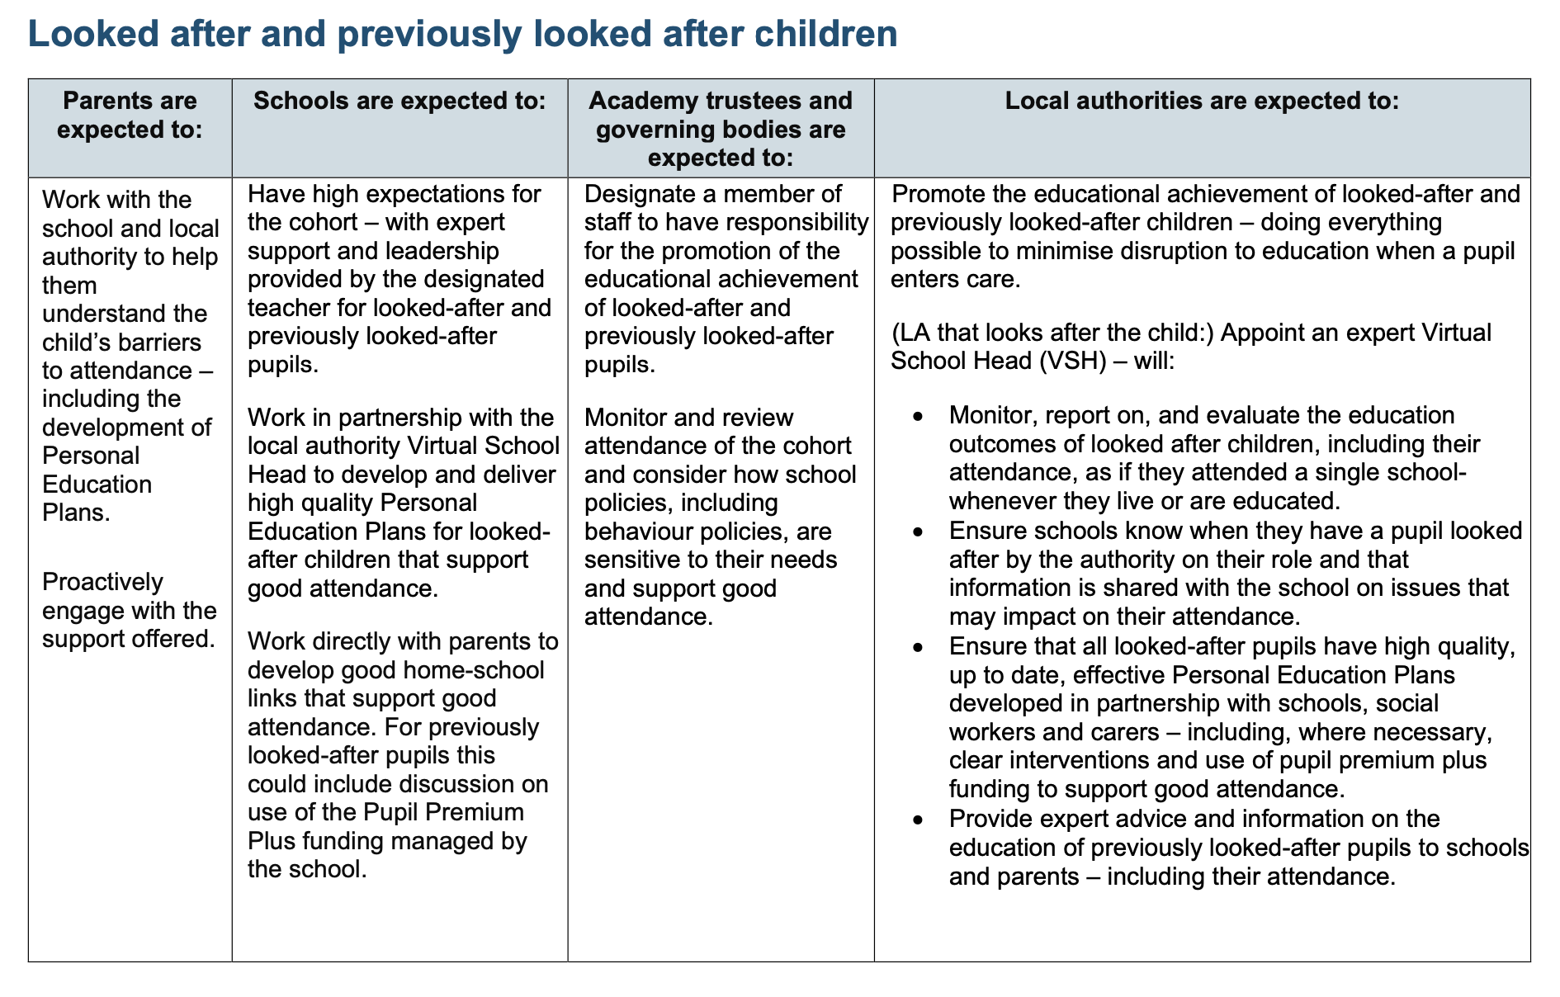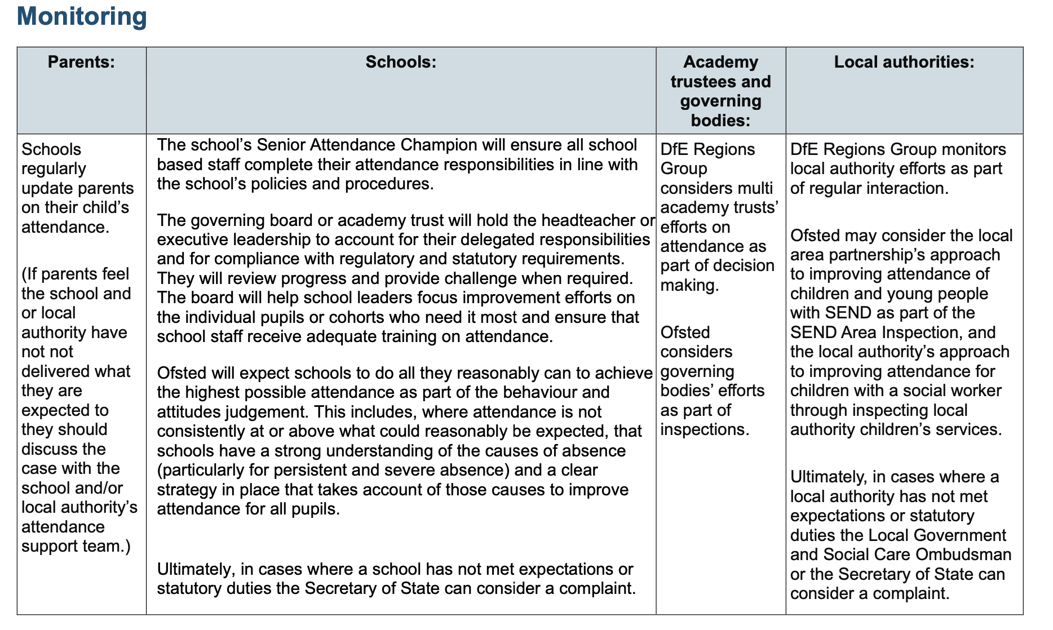
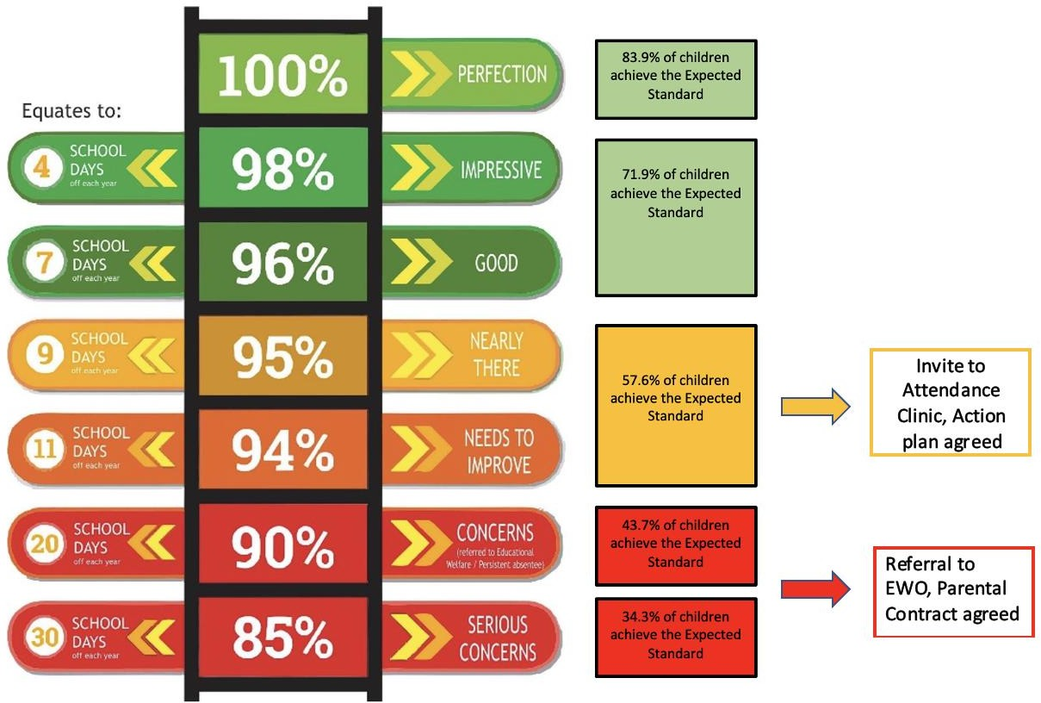
Appendix 4: Reducing Persistent Absence

