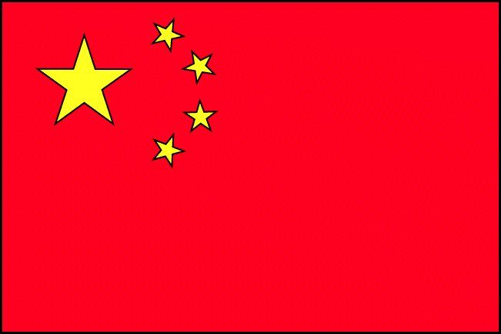

**Mathematics**

* Fractions
* Addition and subtraction
* Time
* 2D and 3D shape
* Money

**Spiritual, Moral, Social and Cultural Development/**

**Living in Modern Britain**

* Significance of Chinese New year

**Geography**:

* Where is China? Use of maps and atlases.
* Comparison of a small Chinese town with Enfield
* What is China like?

**Computing:**

Children to return to mainstream classes for computing

**French:**

Colours

Days of the week

**Learning Journey**

**Class:** Rainbow **Year Group:** 1/2 **Term:** Spring 2

**Title:** China

**Home Learning**

* Reading
* Weekly Maths
* Weekly task linked to CLJ or literacy

**Science**

Animals including humans

* Identify and name a variety of common animals
* fish, amphibians, reptiles, birds and mammals
* Carnivores, herbivores and omnivores
* Parts of the human body

**Physical Development**

Children to return to mainstream class for PE

Indoors – Daily Take 10, weekly session in the soft room

Outdoors – Parachute games, bikes, zed bugs, scooters, trampoline, ball games, skipping

* Pupils to work on personalised targets
* Circle time, relaxation and calming down to develop social and personal skills

**SEAL**:

* Getting on and falling Out

**Chesterfield Values:**

* Friendship

**Art**:

Exploring techniques in working with play dough and clay. To produce and paint a clay piece modeled on figures in the terracotta army.

**Music:**

* Children to learn the song ‘Gung Hay Fat Choy’ about chinese new year, as well as the actions.

<http://www.nancymusic.com/Gunghayplay.htm>

**Drama:**

Role play area to be made into a Chinese restaurant

**Expressive Arts & Design**

**Personal, Social & Emotional Development**

**English,**

**Communication & Language**

Core texts:

* Fairy Tales – 3 Little Pigs
* Fairy Tales – Cinderella

Grammar Focus:

* Full stops, capital letters, finger spaces, Fred Talk, connectives, adjectives

Learning Journey:

* Make a non-chronological report using facts about China

**Spoken Language**:

* Read aloud poetry
* Role play – Chinese restaurant

**Religious Education**

Children return to mainstream classes for RE.

**Understanding the World**